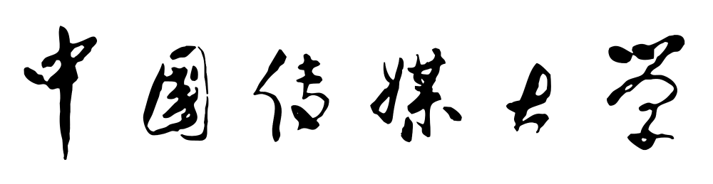

中国传媒大学研究生在读证明

XXX，男/女，学号xxxxxxxxxxxx，生于xxxx年xx月xx日，现为我校xxx专业xxxx方向硕士研究生，学制三/两年，入学时间为xxxx年xx月，预计于xxxx年xx月毕业，特此证明。
中国传媒大学新闻学院
2019年12月03日
照片贴此处（加盖公章）

CERTIFICATION
We confirm here with that Mr./Ms.xxxxxxxx, student ID xxxxxxxx, born on xxxxxxxx, is now studying in the three/two-year graduate program for Master’s Degree at Communication University of China. She has been enrolled in the School of Journalism, majoring in xxx from xxxxxxxx to present. She will graduate in xxxxxxxx.

School of Journalism
Communication University of China
Beijing, PR China

Date(Month/Day/Year): xxxxxxxx

